**Using the Skycoin Wallet**

**Sending Coins (Simple Send)**

1. Open the Skycoin application. After your wallet has been synched check your Skycoin balance.

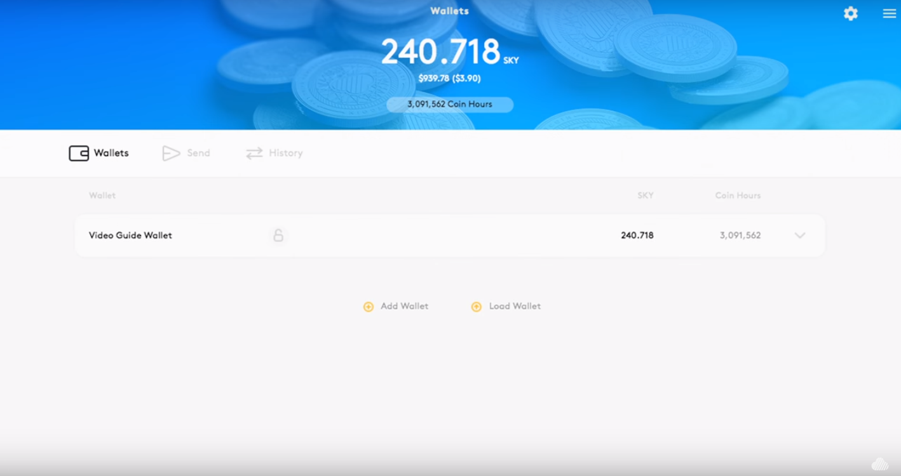

1. Click on the **Send** tab

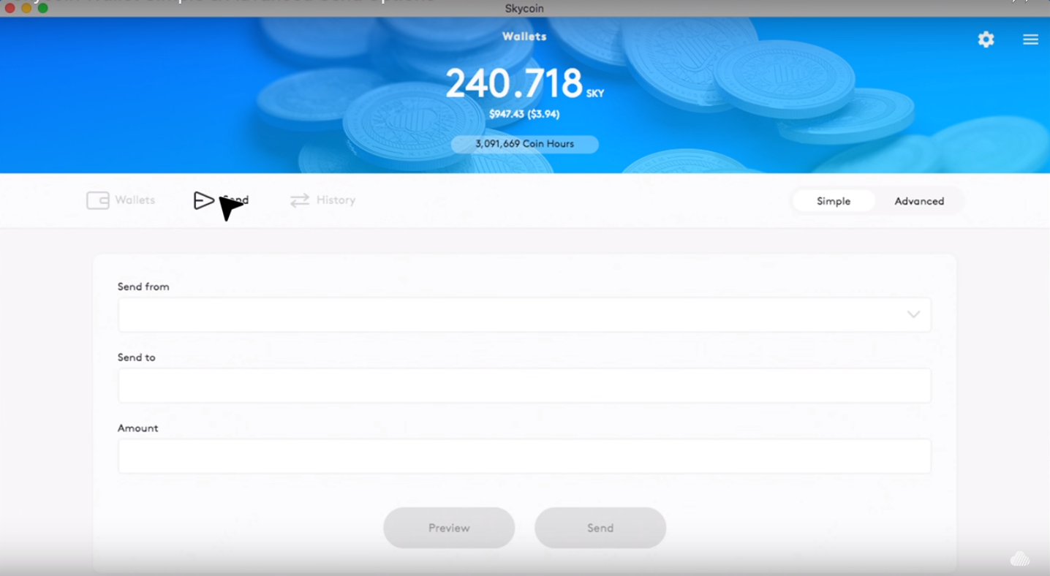

1. You are given the choice between **Simple** and **Advanced** send. Ensure **Simple** is selected.

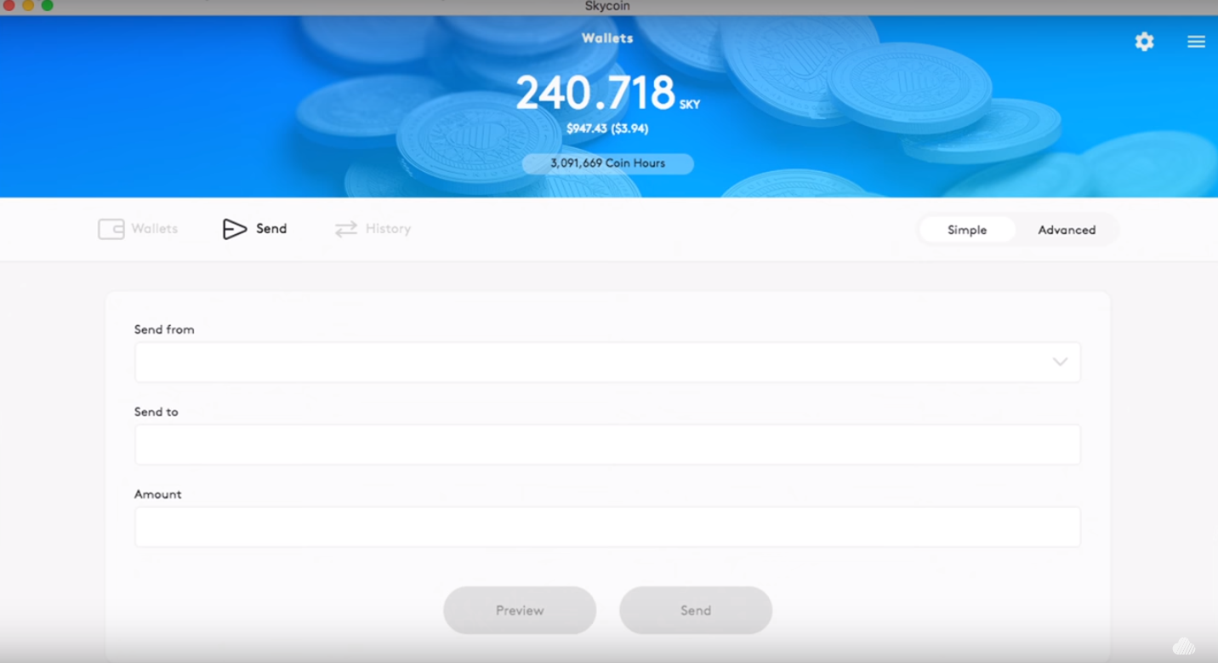

1. Click on the **Send From** box and select the wallet you will be sending coins from.

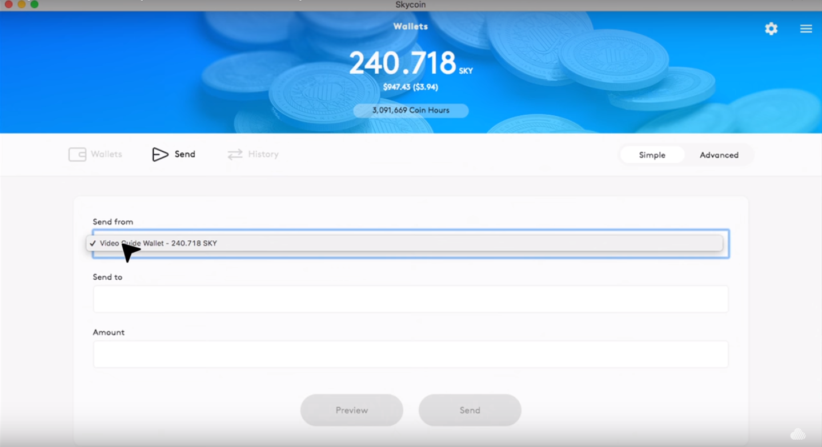

1. In the **Send to** box add the Skycoin address you wish to send the coin to. ***(Note – Make sure you are entering the correct address or the coins may go to the wrong recipient)***

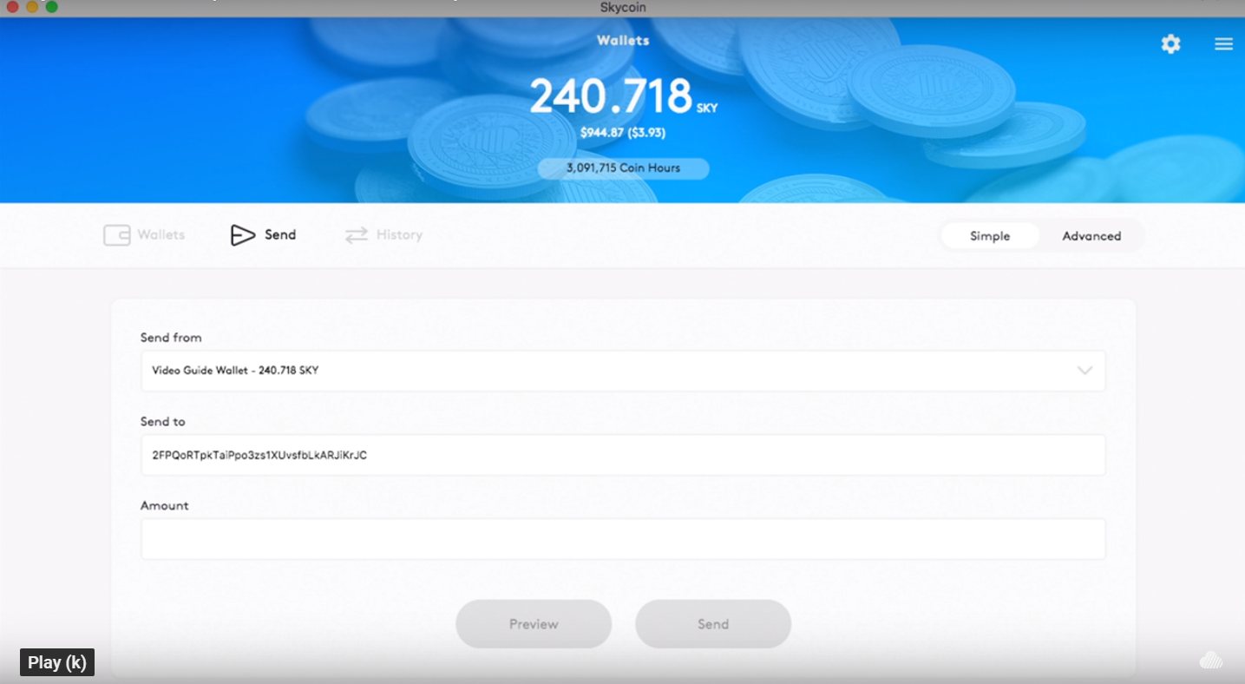

1. In the **Amount** box add in the amount of Skycoin you wish to send to the recipient’s wallet.

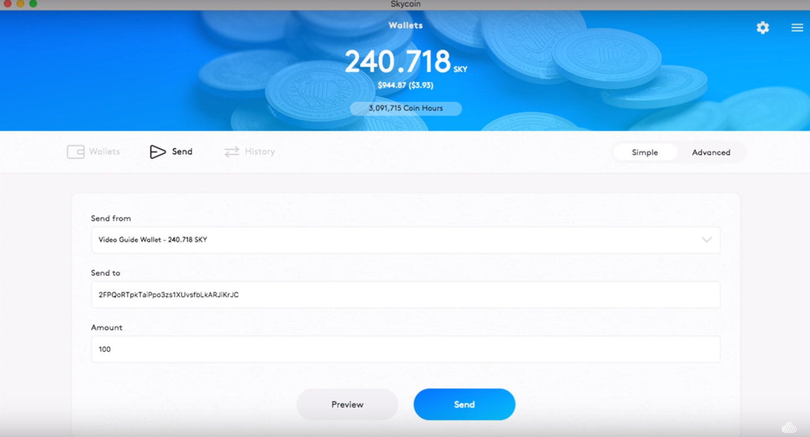

1. Select **Preview** to preview the transaction before it is sent.
   1. Check the amount of coin hours that will be sent to each address.
   2. Check the amount of Skycoin you are sending.

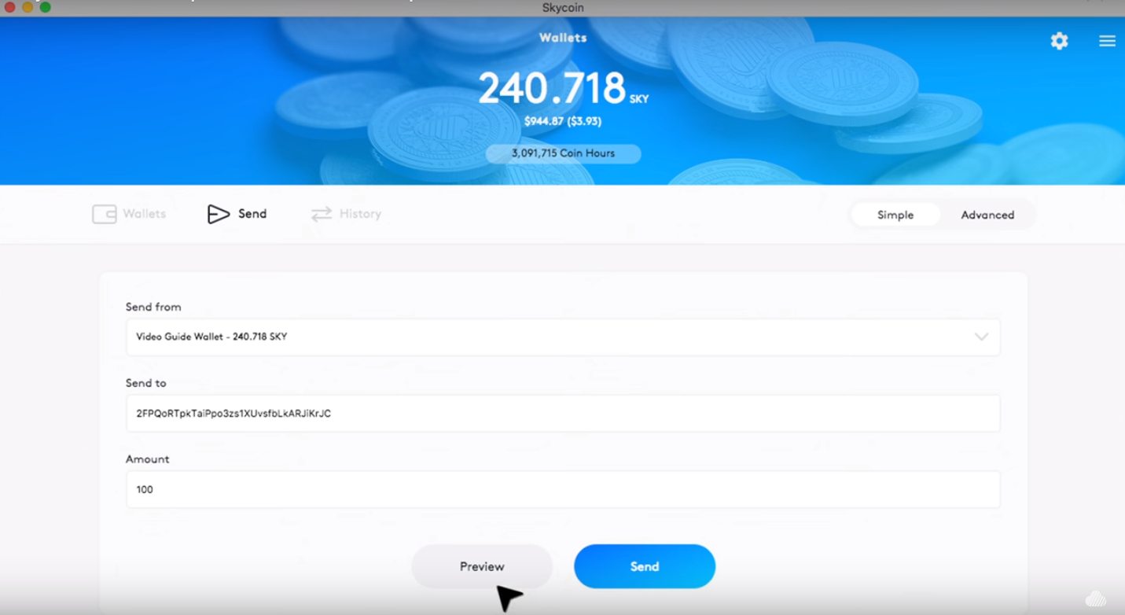

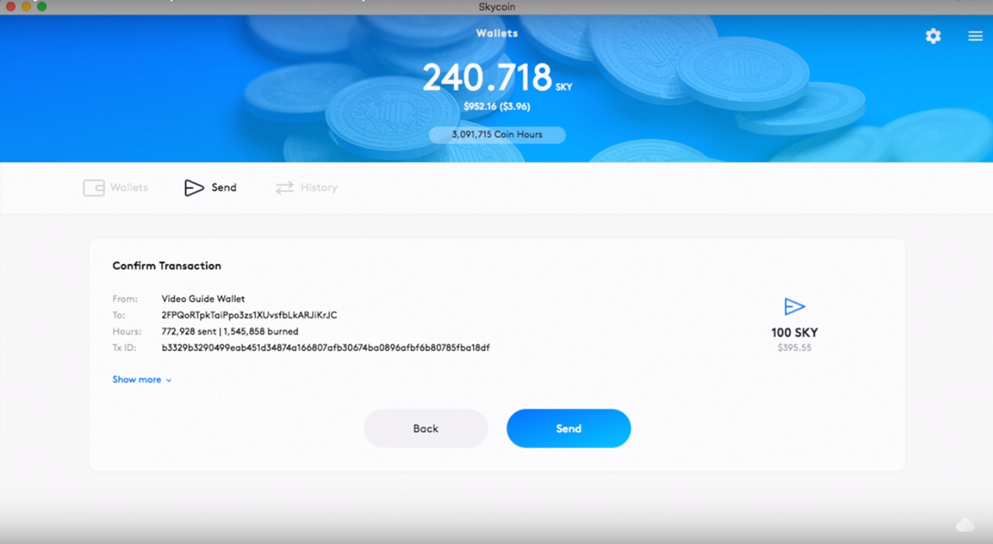

1. Clicking **Show more** (Not required) will display the inputs and outputs for each transaction.

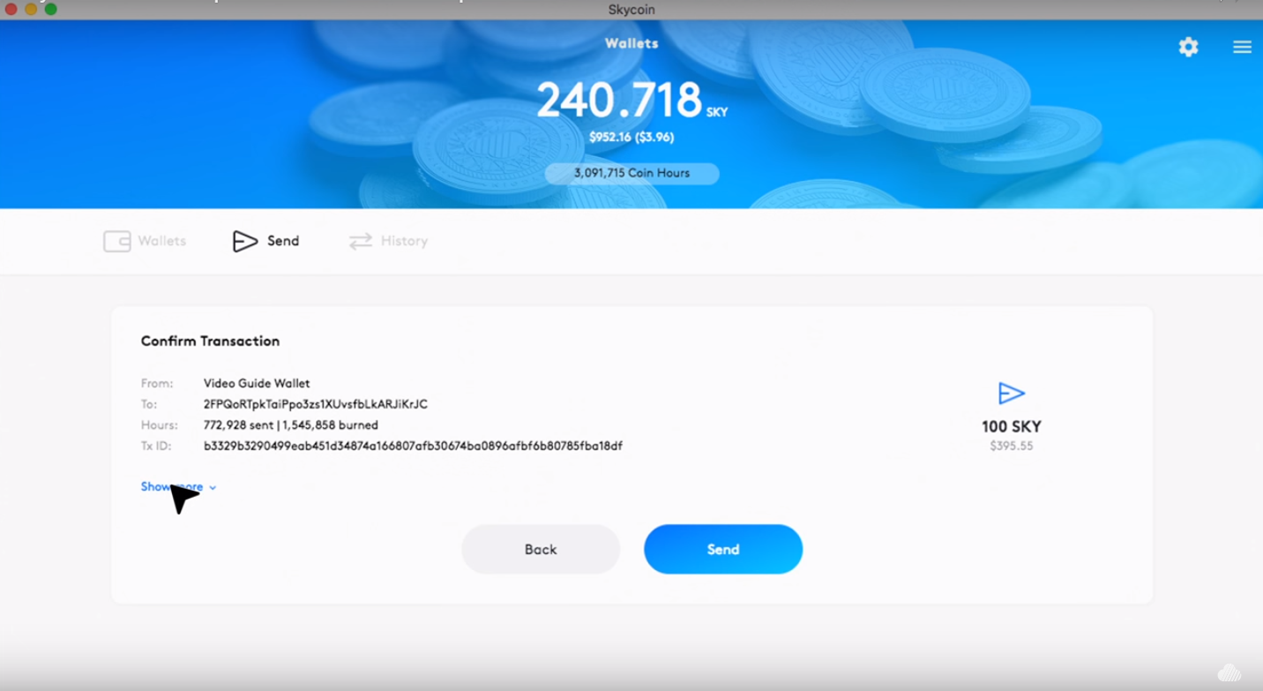

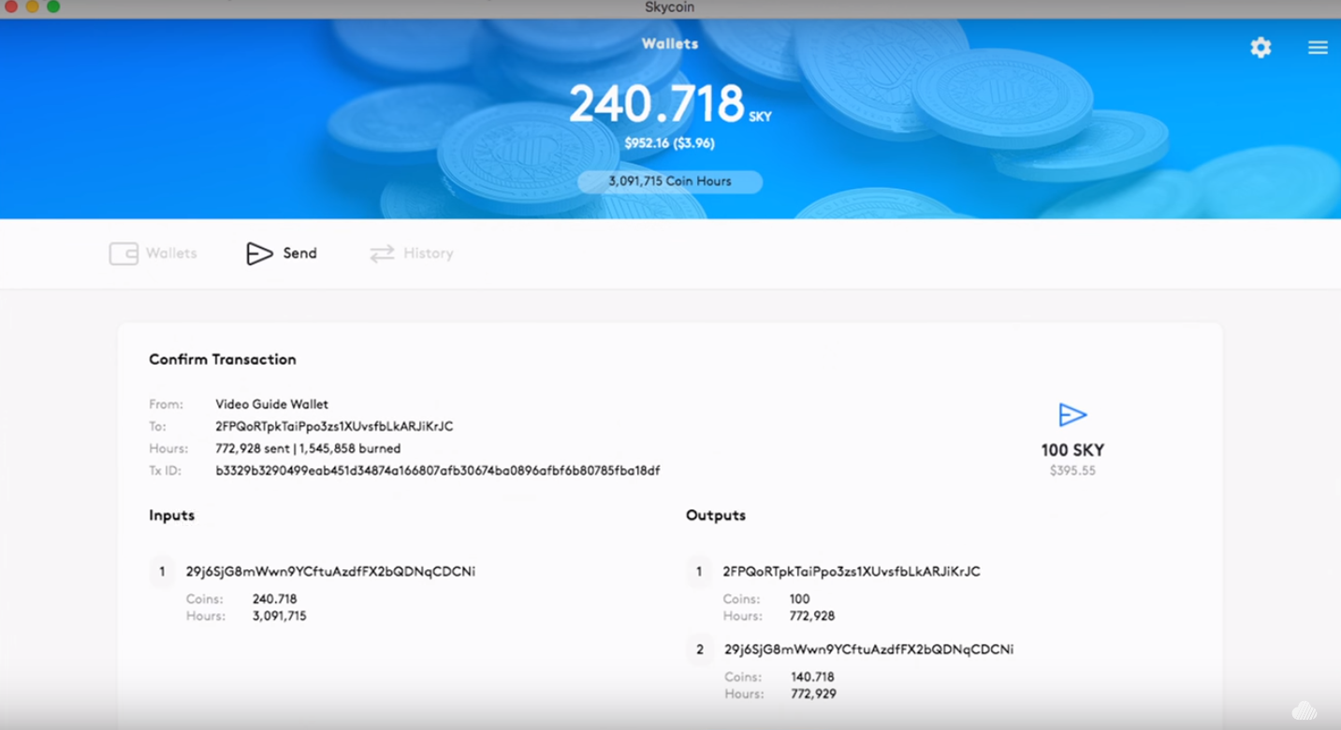

1. Once you have verified the recipients address and the amount being sent click **Send**.

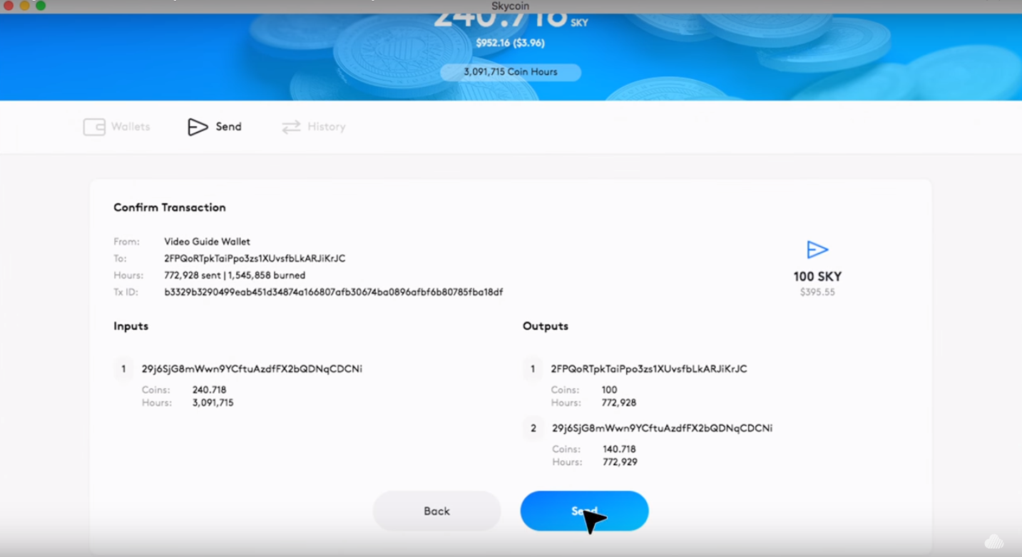

Once **Send** is selected the Skycoin will be sent to the recipient’s wallet.

**Sending Coins (Advanced)**